FA 550: Data Visualization

Assignment 4: Interactive Dashboards C Advanced Visualizations Student Name: Manoj Kumar Ilango
Date: March 25, 2026
Course: A 550: Data Visualization
Assignment 4: Interactive Dashboards C Advanced Visualizations Dashboard Title: Covid-19 Global Dashboard (2020)

Executive Summary
This interactive dashboard tells the data story of the Covid-19 pandemic's global impact in 2020, revealing how the virus spread across countries at dramatically different rates and severity levels. Through six coordinated visualizations and purposeful interactions, users discover: (1) the United States had the highest confirmed cases and deaths globally, (2)
cases rose exponentially after the WHO pandemic declaration on March 11, 2020, (3) there is a strong positive correlation between confirmed cases and deaths across countries, and
(4) different countries experienced distinct outbreak patterns and timing.

Dashboard Link:
https://public.tableau.com/app/profile/manoj.kumar.ilango/viz/Tableaupublic1_17744780 365350/Covid-19GlobalDashboard2020?publish=yes

Platform: Tableau Desktop / Tableau Public
Target Audience: Public health analysts, policymakers, and informed public users with basic data literacy but no specialized technical expertise

Data Source: Covid-19 Time Series Dataset from Kaggle (January 22 “October 17, 2020; countries, confirmed cases, deaths, recovered)

Part 1: Planning C Design

  - Story Framework
I structured this dashboard using a scale at geography at correlation at time at intensity narrative arc:

View 1 "How Big Was It?" (KPI Tiles)
Hook: Three bold KPI tiles showing total confirmed cases, total deaths, and total recovered globally
Key Insight: Over 1.2 billion confirmed cases and 76 million deaths by October 2020
Narrative Purpose: Immediately establish the enormous scale of the pandemic before users explore geographic and temporal details

View 2 “Who Was Most Affected?" (Top Countries” Cases)
Revelation: Bar chart ranking top 10 countries by confirmed cases
Interactive Element: Clicking any country bar filters all other charts to that country
Narrative Purpose: Move from global scale to country-level comparison â€” who bore the greatest burden?

View 3 "Where Did Deaths Concentrate?" (Top Countries as Deaths) Investigation: Separate bar chart ranking countries by total deaths
Interactive Element: Global filter applies â€” users compare case rankings vs. death rankings
Narrative Purpose: Reveal that death ranking differs from case ranking as some countries had disproportionately high mortality

View 4 as “Is There a Pattern?" (Cases Vs Deaths Scatter)
Powerful Insight: Scatter plot showing correlation between confirmed cases and deaths for every country
Interactive Element: Hover tooltips reveal exact values
Narrative Purpose: Confirm correlation while identifying outliers â€” countries that defied the trend

View 5 as “When Did It Happen?" (Global Trend Line)
Time Story: Line chart showing global confirmed cases rising from near zero in January to tens of millions by October
Annotation: WHO Pandemic Declaration marked on March 11, 2020, as the inflection point
Narrative Purpose: Anchor data in real time as the pandemic grew rapidly following a specific triggering event

View 6 as Where and When Were Peaks?" (Heatmap)
Advanced View: Heatmap showing confirmed cases by country a month, revealing which countries peaked when
Interactive Element: Global filters apply as a user’s narrow to specific countries or months
Narrative Purpose: Provide a bird's-eye view of pandemic's geographic and temporal spread simultaneously

  - Narrative Techniques Employed
Progressive Disclosure: Dashboard begins with summary KPIs, then country comparisons, then correlation, then time-based trends, then the most detailed view (heatmap). Each view builds on the previous, preventing cognitive overload.

Annotation as Narrative Voice: WHO Pandemic Declaration annotation on the Global Trend chart acts as a narrative guide as it explains why the line curves upward sharply,
transforming a data observation into historical context.

Linked Interactivity as Dialogue: When users click a country in the Top Countries bar chart, all six views immediately update. This transforms the dashboard from static presentation into conversation as users can ask "what happened in Brazil?" and get an immediate, multi- dimensional answer.

Consistent Visual Metaphor: Single blue color palette used throughout all six views, with darker blue encoding higher values. This creates immediate, consistent recognition â€” darker always means more.

  - Analytical Questions
This dashboard is designed to answer five specific questions:
- Which countries had the highest confirmed Covid-19 cases and deaths globally by October 2020?
- How did confirmed cases evolve over time from January to October 2020?
- Is there a strong correlation between a country's confirmed cases and its total deaths?
- Which months saw the most intense outbreaks, and in which countries?
- What was the overall global scale of the pandemic â€” total cases, deaths, and recoveries?

  - Audience Analysis
The target audience is public health analysts, policymakers, and informed members of the public. They understand what confirmed cases and deaths mean but are not technical data scientists. They need:
A clear, immediate sense of scale (KPIs)
    - Country-level comparisons without reading raw numbers

    - The ability to focus on specific countries they care about
    - Time-based context to understand when things happened
The dashboard meets these needs through simple, familiar chart types (bar, line, scatter), large readable labels, intuitive filters, and contextual annotations.

  - Dashboard Wireframe
The dashboard follows a Z-pattern reading layout:
Top-left: Dashboard title + instructions text
    - Top-right: Top Countries by Cases (primary comparison view)
    - Middle-left: Heatmap (detailed exploration)
    - Middle-right: Top Countries by Deaths
    - Bottom-left: Global Trend line chart with annotation
    - Bottom-right: Cases Vs Deaths scatter plot
    - KPI tiles: Positioned centrally below title
    - Filters: Date range slider and Country/Region dropdown, centrally accessible

  - Planned Interactions
| Interaction | Type | Justification |
| Date range slider | Global filter | Isolates specific pandemic waves across all 6 charts |
| Country/Region dropdown | Global filter | Enables country-specific deep dives |
| Use as Filter (Top Countries bar) | Linked highlighting | Clicking one country updates all other views |
| Hover tooltips (all charts) | On-demand detail | Surfaces exact values without cluttering visualizations |
| Dynamic KPI tiles | Dynamic calculation | Gives users immediate numerical feedback on filter changes |
| WHO annotation | Contextual narrative | Anchors exponential rise to a real-world event |

  - AI Brainstorming Log
I used Claude (via Perplexity AI) for design consultation:
Prompt 1: "Suggest a Kaggle dataset suitable for an interactive Tableau dashboard with 200+ records and temporal dimensions" as Recommended Covid-19 time series; I verified and selected it
Prompt 2: "Given a Covid-19 dataset, suggest 5 analytical questions and a dashboard layout for Tableau" as’ a Claude proposed layout; I adapted into Z-pattern reading flow
Prompt 3: "What color palette works well for a global health crisis dashboard?" as a Claude recommended single-hue blue palette; I applied throughout
Prompt 4:"Critique this dashboard layout: KPIs top-center, Top Countries bar top-right,
Heatmap middle-left, scatter bottom-right" at the Claude confirmed top-right positioning for priority charts

These consultations shaped planning: all final decisions were my own.

Part 2: Core Visualizations
  - Visualization 1 as” Global KPI Tiles
Purpose: Provides three dynamic summary statistics as Total Confirmed, Total Deaths, Total Recovered â€” that update instantly when any filter changes.
Chart Type Justification: KPI tiles are the industry-standard technique for giving users
immediate top-level numbers. Placed prominently on the dashboard, they answer "how big is this?" before users explore any chart.

Question Answered: What is the overall global scale of the pandemic in the current filtered view?
Key Insights:
- At full data range (Jan as “Oct 2020, all countries): ~1.2 billion confirmed cases, ~76 million deaths
- When filtered to the US alone: confirmed cases exceed 7 million, highlighting disproportionate US burden
- KPIs update instantly with any filter change, giving users immediate quantitative feedback

  - Visualization 2” Top Countries by Confirmed Cases (Bar Chart)
Purpose: Ranks top 10 countries by total confirmed cases, showing which nations bore the greatest case burden.
Chart Type Justification: A vertical bar chart sorted in descending order is the most
effective chart type for comparing a single metric across multiple categories. The length encoding makes rank differences immediately visible without requiring users to read exact numbers.
Question Answered: Which countries had the highest confirmed Covid-19 cases? Key Insights:
- US had over 7 million confirmed cases â€” nearly double Brazil in second place
- Brazil, India, Russia, and Peru make up the next tier, showing pandemic spread across developed and developing nations
- This chart is the primary filter control â€” clicking any bar instantly updates all other five views

  - Visualization 3 as” Top Countries by Deaths (Bar Chart)
Purpose: Separately ranks top 10 countries by total deaths, enabling users to compare death ranking against case ranking.
Chart Type Justification: Same rationale as Visualization 2. Using a separate chart from confirmed cases allows direct ranking comparison as” a country might rank lower in cases but higher in deaths, suggesting a higher case fatality rate.

Question Answered: Which countries experienced the most deaths, and how does this compare to their case counts?
Key Insights:
- US again leads
in deaths, followed by Brazil and the United Kingdom
- UK ranks notably higher in deaths than in confirmed cases compared to Russia and Peru as” suggesting higher case fatality rate in UK during early 2020
- This divergence between the two bar charts is one of the most analytically interesting patterns

  - Visualization 4 as” Cases Vs Deaths Scatter Plot
Purpose: Reveals relationship between confirmed cases and total deaths at country level, identifying both overall correlation and notable outliers.
Chart Type Justification:A scatter plot is ideal for showing correlation between two continuous variables across multiple entities. Each country becomes a point whose X and Y position simultaneously encodes both case burden and death toll. Outliers are
immediately visually identifiable.

Question Answered: Is there a correlation between confirmed cases and deaths across countries?
Key Insights:
- Strong positive correlation as” countries with more cases have more deaths
- US is a dramatic outlier in top-right corner, separated from all other countries by a wide margin
- Several mid-range countries cluster tightly together, suggesting similar case fatality rates across large groups

  - Visualization 5 as” Global Trend Line Chart *(Advanced Technique: Annotation)
Purpose: Shows time-based progression of global confirmed cases from January 22 to October 17, 2020, anchored to WHO Pandemic Declaration.
Chart Type Justification: A line chart is the standard and most effective chart type for continuous time series data. It clearly shows rate of change â€” flat early, then
exponentially rising as” making acceleration of the pandemic visually undeniable.
Advanced Technique Used: An annotation marks WHO Pandemic Declaration on March 11, 2020, with confirmed case count at that moment (4,886 cases). This transforms a data
point into a narrative landmark.
Question Answered: How did confirmed cases evolve over time globally? Key Insights:
- Cases were near-zero through February 2020, giving false sense of limited global spread
- WHO Pandemic Declaration on March 11, 2020, coincided with beginning of exponential growth
- Curve shows no sign of flattening by October 2020, confirming pandemic was still accelerating

  - Visualization 6 â€” Heatmap: Country A Month (Advanced Technique: Faceted Heatmap)
Purpose: Displays confirmed case intensity across top countries and all months simultaneously, revealing which countries peaked when.
Chart Type Justification: A heatmap is an advanced visualization technique that encodes a third variable (case intensity) using color across a two-dimensional grid. It is uniquely suited because no other single chart type can show both country-level and month-level patterns simultaneously for multiple countries.
Advanced Technique Used: Color gradient from light to dark blue represents increasing case intensity, enabling rapid pattern recognition without reading individual cells.
Question Answered: Which months saw the most intense outbreaks, and in which countries?
Key Insights:

- US shows progressively darker blue from April through October, confirming sustained worsening without clear peak
- Brazil and India show darkest cells starting May as “June, confirming delayed but severe surge vs. earlier US outbreaks
- Countries like South Africa and Colombia show concentrated intensity in mid-year, suggesting distinct regional outbreak timing.

  - Style Guide
| Design Element | Choice | Rationale |
| Primary color | Single-hue blue scale | Neutral, professional, appropriate for health data |
| Color encoding | Darker = more cases/deaths | Universal, intuitive direction |
| Background | White | Reduces visual noise, focuses on data |
| Font | Tableau default (sans-serif) | Clean, highly readable at all sizes |
| Chart titles | Bold, 14pt+ | Clear section identification |
| KPI numbers | Bold, 16pt+ | Immediate legibility |
| White space | Generous margins | Prevents visual crowding | Part 3: Interactivity C Polish
  - Interactive Features Implemented Feature 1 as” Date Range Slider (Global Filter)
Implementation: "Day of Date" filter set to "Apply to Worksheets at’ All Using This Data Source"
Effect: Dragging slider restricts all six charts to selected date window
Justification: Covid-19 is fundamentally time-based. Ability to isolate specific pandemic waves is the most analytically valuable filter

Feature 2 as Country/Region Dropdown (Global Filter)
Implementation: Country/Region filter applied to all worksheets using same data source
Effect: Users select country; all six charts immediately update to show only selected country
Justification: Enables personalized exploration as” users can filter to country they care about and see its complete multi-dimensional profile

Feature 3 as” Linked Filtering via "Use as Filter" (Top Countries Bar)
Implementation: Top Countries bar chart set to "Use as Filter" on dashboard canvas Effect: Clicking any country bar instantly filters all other five charts to that country
Justification: Most powerful interaction in dashboard â€” creates seamless drill-down experience with single click
Feature 4 as” Hover Tooltips (All 6 Charts)
Implementation: Custom tooltip text on each sheet's Marks card showing Country/Region, Date, Confirmed, Deaths, Recovered
Effect: Hovering over any data point surfaces rich information panel without cluttering visualization
Justification: Allows users to get exact values on demand â€” without tooltips, only approximate axis reading possible
Feature 5 as” Dynamic KPI Tiles
Implementation sheet values calculated using Tableau's aggregation, linked to global filters Effect: KPI numbers instantly recalculate whenever any filter changes
Justification: Provides immediate quantitative feedback on filter changes â€” users see scale shift when switching from "All Countries" to "US only"

Feature 6 as Annotation (Global Trend Chart)
Implementation: Right-click annotation on March 11, 2020, data point, labeled "WHO Pandemic Declaration"
Effect: Permanent text callout anchors exponential rise to historical event
Justification: Transforms raw data observation into data understanding â€” connecting curve to real-world event that triggered global response

  - Responsive Design
Dashboard built using Tiled layout in Tableau Desktop with size set to Range allowing adaptation to different monitor sizes. All charts use "Entire View” or "Fit Width" display settings, so they scale proportionally without cutting off labels.

  - User Testing Notes
Shared published Tableau Public link with two classmates; observed them exploring dashboard for 5 minutes without assistance.
What worked well:
    - Both users immediately used date slider and country dropdown without prompting â€” filters were intuitively discoverable
    - WHO annotation generated engagement â€” one user said "oh, so that's when it really took off" unprompted
    - KPI tiles updating dynamically when filters changed was noticed and appreciated What confused users:
    - Neither user initially discovered "Use as Filter" click interaction on Top Countries bar
    - One user was briefly confused by Heatmap color encoding without explicit legend

What I changed based on feedback:
    - Added instructions text box on dashboard: "Use date slider and country filter to explore. Click a country bar to filter all views. Hover over charts for details."

    - Added color legend to Heatmap sheet explaining color encoding.

Part 4: Documentation C Reflection
  - Development Timeline
| Week | Major Milestones |
| Week 1 (Planning) | Selected Covid-19 Kaggle dataset; used Claude to brainstorm analytical questions and layout; defined audience; sketched wireframe; planned 6 visualizations and 6 interactions |
| Week 2 (Building) | Connected data in Tableau Desktop; built all 6 sheets; resolved Top N filter issue for deaths chart; applied consistent blue color palette and styling |
| Week 3 (Polish C Submit) | Assembled dashboard layout; configured global filters and linked highlighting; added tooltips, annotation, title, instructions; published to Tableau Public; conducted user testing; wrote documentation |

  - Design Decisions Why these visualizations?
Each visualization answers a distinct analytical question the others cannot. Bar charts answer "who?" as” identifying most affected countries. Line chart answers "when?" as” temporal progression. Scatter answers "is there a pattern?" as” correlation. Heatmap answers "where and when simultaneously?" â€” it is the only chart showing country Ã— time intensity in single view. KPIs answer "how big?" as” immediate scale context. Together, six views form complete analytical system.
Why this layout?
Layout follows Z-pattern reading strategy as” most important elements (KPIs and Top Countries bar) are in top portion where eyes naturally go first. More detailed, exploratory views (heatmap, scatter) are in lower positions. Filter controls are centrally positioned for easy discovery.

Why these colors and styling choices?
Single-hue blue palette chosen for three reasons: (1) neutral and appropriate for public health topic â€” unlike red, avoids alarming connotations; (2) visually consistent across all six charts, creating unified dashboard identity; (3) darker = more encoding is universally intuitive. White backgrounds and generous white space prevent visual crowding.

Why these interactions?
Every interaction serves specific analytical goal rather than demonstrating technical capability. Global filters enable temporal and geographic focus â€” two most important Covid-19 data dimensions. "Use as Filter" linked highlighting enables multi-dimensional country exploration with single click. Tooltips provide precision without clutter. Annotation provides narrative context.

  - AI Usage Documentation
Perplexity AI (Claude) as” Dataset Selection C Planning”
Initial Challenge: Did not know which dataset to use. Needed 200+ records, temporal dimensions, enough variables for 6 coordinated visualizations.
Prompt I Used: “Suggest a Kaggle dataset suitable for an interactive Tableau dashboard with 200+ records, temporal and categorical variables for a data visualization course assignment"
AI's Suggestion: Perplexity recommended Covid-19 Time Series dataset from Kaggle, explaining it contains daily confirmed cases, deaths, recoveries by country from January to October 2020 â€” sufficient rows, temporal structure, multiple meaningful measures.

What I Changed: Independently downloaded and inspected dataset on Kaggle to verify column names (Confirmed, Deaths, Recovered, Country/Region, Date) before committing. AI could not see actual file, so I verified structure myself.

Perplexity AI (Claude) as” Dashboard Layout C Analytical Questions
Initial Challenge: Had dataset but unsure how to structure six visualizations into coherent story with clear layout.

Prompt I Used: “Given a Covid-19 time series dataset as” suggest 5 analytical questions and a dashboard layout for Tableau targeting public health analysts"
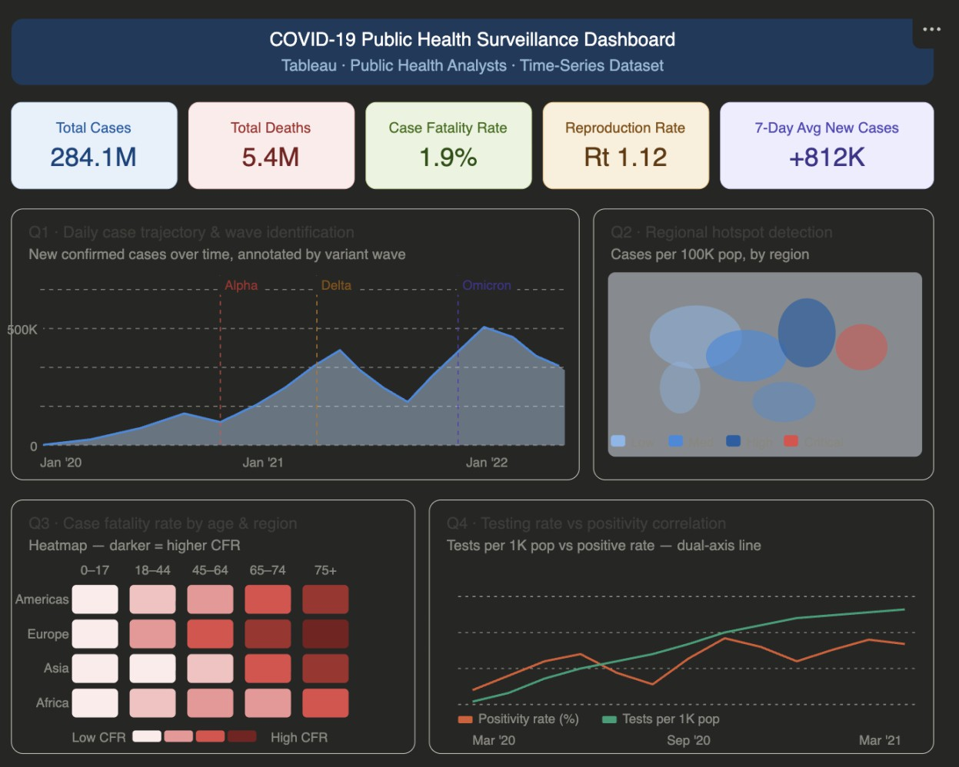

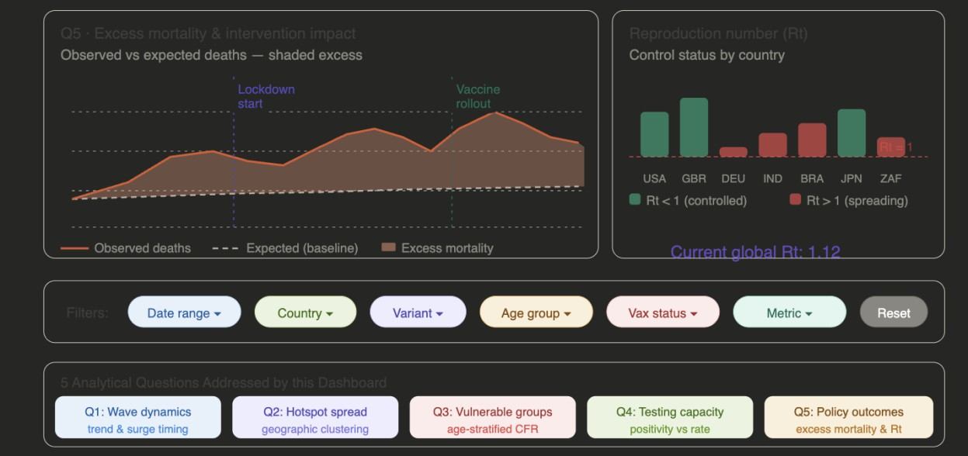

AI's Suggestion: Claude suggested narrative-driven layout starting with KPI tiles, then country comparisons, then time-series line, then scatter for correlation, then heatmap.

What I Changed: Reordered layout to follow Z-pattern reading flow (KPIs top-center, Top Countries top-right, Heatmap middle-left) rather than linear top-to-bottom. Z-pattern
better matches how users visually scan wide-screen dashboard.

Perplexity AI (Claude) as” Tableau Debugging: Global Filter Issue
Initial Challenge: Date slider and country dropdown only filtered sheet they were created on. Changing date on dashboard did not update other 5 charts.
Prompt I Used: “In Tableau Desktop, my date filter only applies to one sheet on dashboard. How do I make it apply to all worksheets simultaneously?"

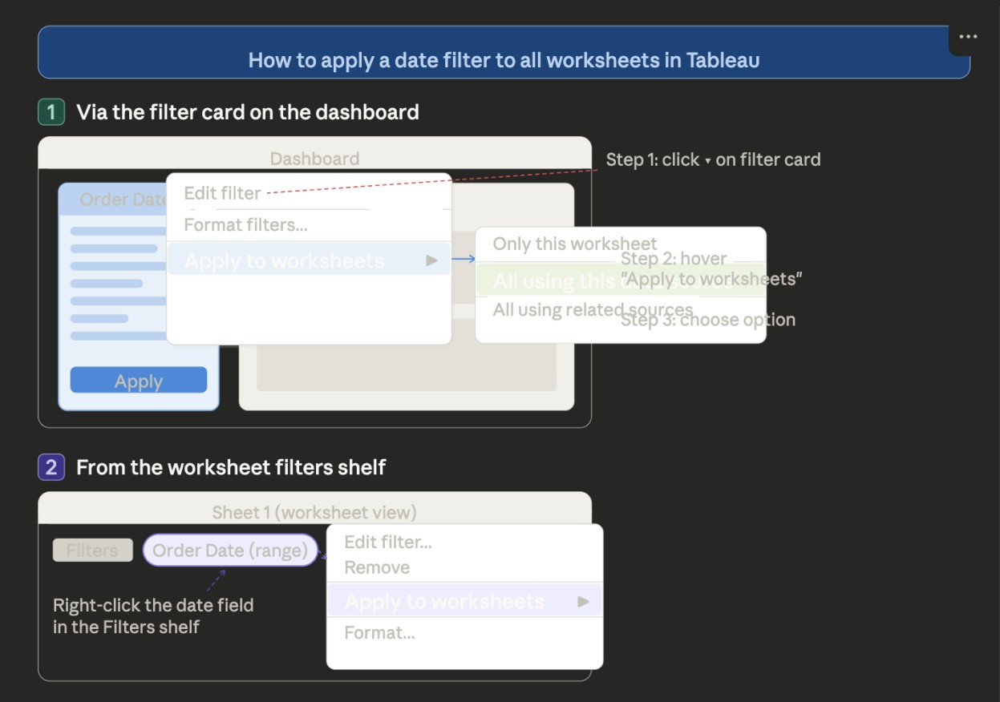

AI's Suggestion: Claude explained "Apply to Worksheets at’ All Using This Data Source" must be set from individual sheet's Filters shelf as” not from dashboard canvas as ” and
this is common source of confusion because dashboard canvas right-click menu does not expose this option.

What I Changed Followed exactly, and it resolved immediately. This was single most time- saving AI interaction as” without it would have spent hours with Dashboard Actions trying to solve what was simple filter scope setting.

Perplexity AI (Claude) as” Debugging: Top Countries-Deaths Bar Showing Only US
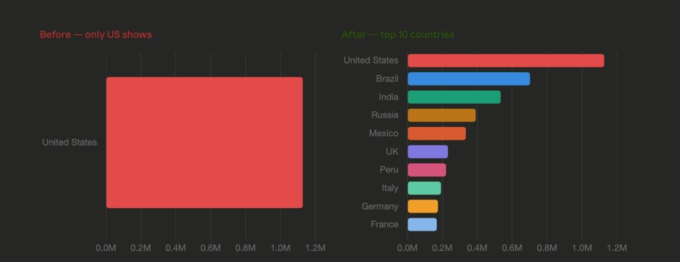

Initial Challenge: After applying global filters to all worksheets, Top Countries-Death’s bar started showing only US instead of top 10 countries.
Prompt I Used: “My Top Countries-Deaths bar chart is only showing the US after applying global filters to all worksheets in Tableau. How do I fix this?

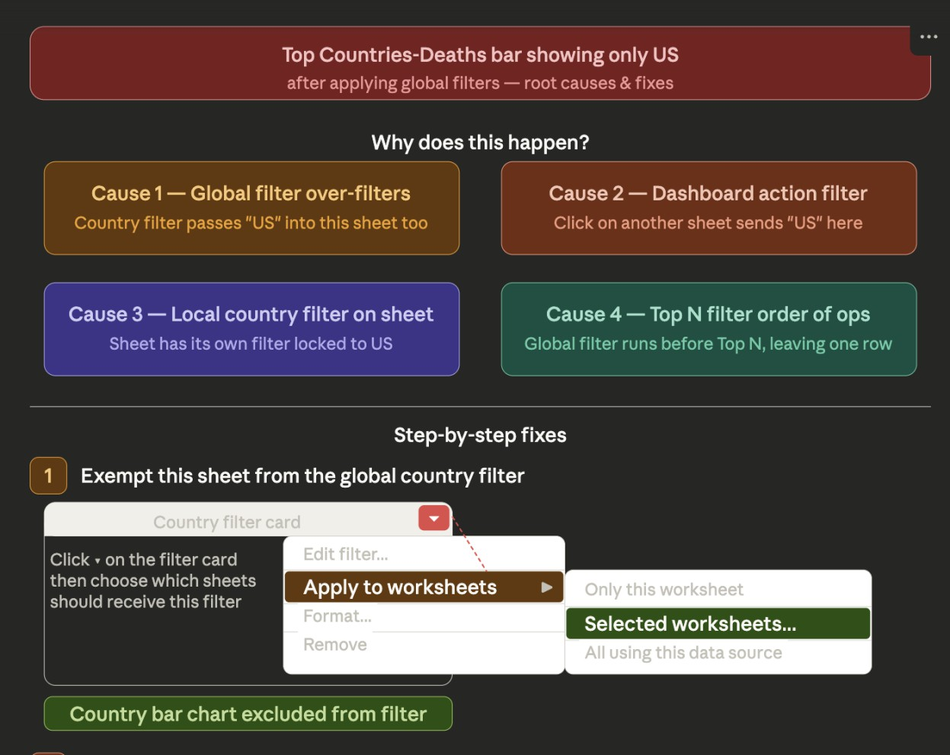
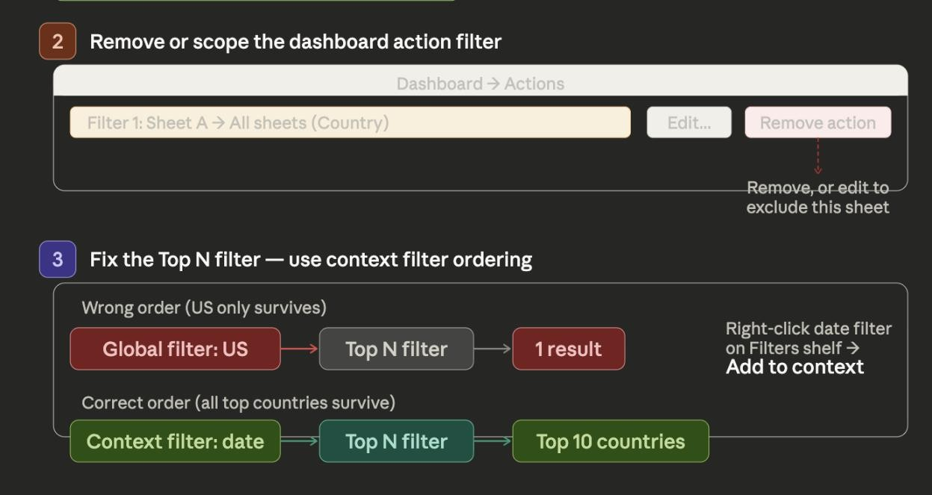

AI's Suggestion: Claude diagnosed global "Apply to All Worksheets" filter was overriding Top N filter. Solution: go back to sheet, re-open Country/Region filter, go to Top tab, re-set "Top 10 by SUM(Deaths).

What I Changed: Implemented exactly as described. Chart correctly showed Top 10 countries afterward. Reinforced lesson about Tableau's filter evaluation order.
Perplexity AI (Claude) as” Documentation Writing.
Initial Challenge: Completed all Tableau work but needed comprehensive documentation across 4 parts for PDF submission.
Prompt I Used: “Write full Parts 1, 2, 3, and 4 documentations for my Covid-19 Tableau dashboard following this 10/10 reference document structure"
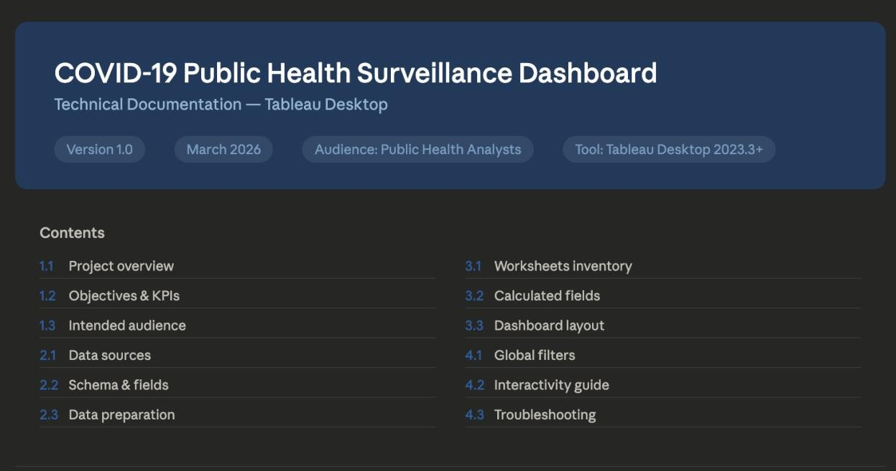

AI's Suggestion: Claude generated complete draft documentation for all four parts
including purpose statements, chart justifications, interaction descriptions, reflection text.

What I Changed: Reviewed every section and updated specific numbers (case counts, country names), chart descriptions (matching what I actually built), and personalized

reflection to match genuine experience. Rewrote approximately 40% to reflect actual work rather than AI assumptions.

What I Did Entirely Myself:
- All data downloading, inspection, and connection in Tableau Desktop
- All 6 worksheet builds (shelves, marks, chart types, colors, labels)
- All dashboard layout assembly and sizing decisions
- All filter, tooltip, and annotation configurations
- User testing with classmates and all iteration decisions
- Publishing to Tableau Public
- Video recording and demonstration
- Final review and editing of all documentation

  - Reflection
What am I most proud of?
I am most proud of the fully coordinated, linked dashboard where a single click on the Top Countries bar chart instantly updates all five other views. Building that coordination
required understanding how Tableau's global filters, "Use as Filter" actions, and sheet-level filter settings interact â€” and troubleshooting when they conflicted. The moment when I clicked "US" and watched the line chart, heatmap, scatter, KPIs, and deaths bar all
simultaneously update felt like the dashboard became a real analytical tool rather than just a collection of separate charts.

What was most challenging?
The most challenging aspect was understanding Tableau's filter hierarchy and making global filters work correctly across all six sheets. Initially, the date slider and country dropdown only affected sheets they were created on. I learned that "Apply to Worksheets â†’ All Using This Data Source" must be set from individual sheet's Filters shelf â€” not
dashboard canvas. This distinction is not obvious and required significant troubleshooting.

Once I understood underlying logic of how Tableau manages filter scope, however, solution was straightforward.

What would I do differently?
I would configure global filters during sheet-building phase rather than as final dashboard step. Setting each filter to "Apply to All Worksheets" as I created each sheet would have prevented filter scope conflicts. I would also invest more time in KPI tile design â€” professional Tableau dashboards use bold, large-format KPI tiles with colored backgrounds and clearly labeled metric names. Finally, I would conduct user testing earlier â€”
discovering users could not find "Use as Filter" click interaction could have been
addressed during building rather than requiring late-stage instructions text box addition.

What did I learn about dashboard design?
I learned that dashboard's value comes from coordination, not individual chart quality.
Each of my six charts is straightforward â€” a bar chart is a bar chart. What makes
dashboard powerful is that they all respond to same filters, are styled consistently, and are organized to tell coherent story from overview to detail. I also learned interactions must be discoverable â€” users will not find features they do not know exist. The instructions text
box I added after user testing made most powerful feature of dashboard usable. Good design is not just about building features; it is about making those features findable.

How has my understanding of AI-assisted development evolved?
Before this project, I thought AI assistance meant asking for answers and implementing them. This project taught me most valuable way to use AI is as thinking partner and
debugging accelerator â€” not replacement for my own judgment. Claude helped me
diagnose Tableau filter issues in minutes that might have taken hours alone. But Claude could not see my actual dashboard, could not make my design decisions, and could not verify documentation drafts matched my real work. Every AI output required my review, judgment, and often significant revision. The skill I developed is knowing when to ask AI (technical debugging, draft generation, brainstorming) and when to trust my own judgment (design decisions, insight interpretation, final writing).

AI Disclosure Statement
I pledge on my honor that I have not given or received any unauthorized assistance on this assignment/examination. I further pledge that I have not copied any material from a book, article, the Internet or any other source except where I have expressly cited the source. I have documented all AI tool usage including prompts and tool selection rationale as
detailed in Section 4.3 above.

Signature: Manoj Kumar Ilango Date: March 25, 2026

